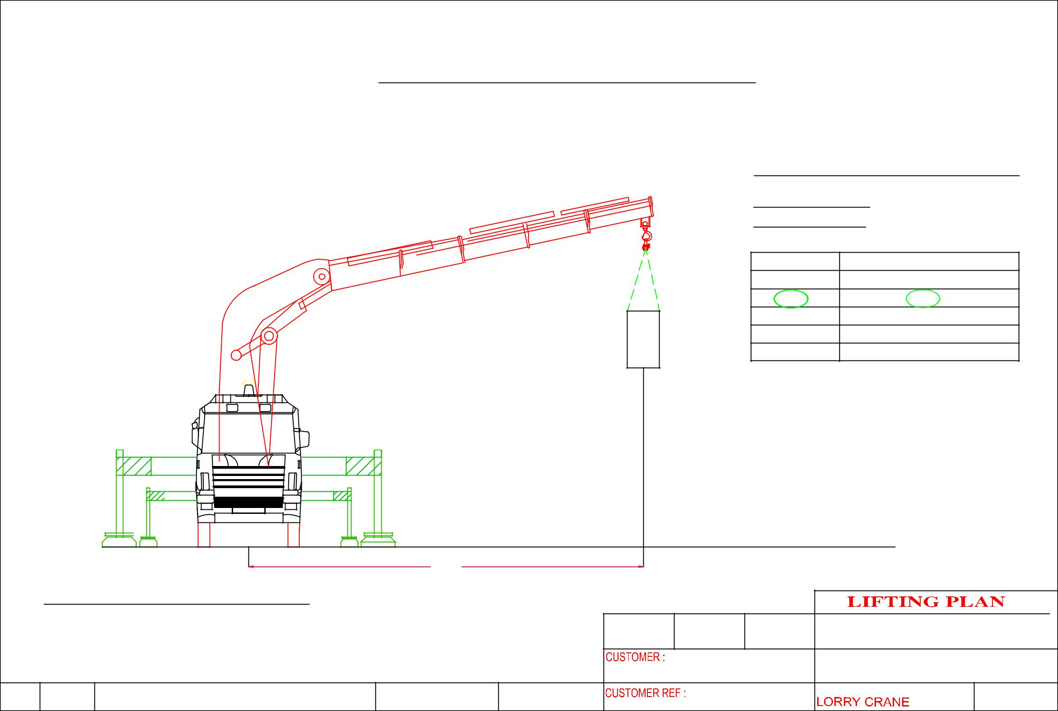
 |  |  | LIFTING PLAN – BlK 5012 A.M.K Ave 5 #01-10 (LHY Engineering (S) PTE LTD)
 |  |  |  |  |  |  |  | CRANE :PALFINGER PK100002E
 |  |  |  |  |  |  |  | LORRY CRANE
 |  |  |  |  |  |  |  | CRANE CONFIGURATI0N
 |  |  |  |  |  |  |  | OPERATING RADIUS : 5.6m
 |  |  |  |  |  |  |  | ^{OPT . RADIUS(m)} |  | LIFTING CAPACITY OF CRANE IN KG
 |  |  |  |  |  |  |  | 4.4 |  |  | 19,000
 |  |  |  |  |  |  |  | 5.6 |  |  | 14,800
 |  |  |  |  |  |  |  | 7.4 |  |  | 10,960
 |  |  |  |  |  |  |  | 9.2 |  |  | 8,630
 |  |  |  |  |  |  |  | 11.1 |  |  | 7,020
 |  |  |  |  | MACHINE WEIGHT | 9,500 KG |  | SAFETY FACTOR CALCULATION
 |  |  |  |  |  |  |  | WEIGHT OF MACHINE |  |  | : 9,500 KG
 |  |  |  |  |  |  |  | LIFTING ACCESSORIES WEIGHT : 100 KG
 |  |  |  |  |  |  |  | TOTAL WEIGHT OF LIFTING |  |  | :9.600KG
 |  |  |  |  |  |  |  | LIFTING CAPACITY |  |  | : 14,800KG
 |  |  |  |  |  |  |  | SAFETY FACTOR |  |  | :1,541 KG
 |  |  |  | 5.6M
 | CRANE :PALFINGER PK100002E
 |  |  |  |  |  |  |  |  | ERIC WONG MACHINERY TRANSPORTATION P/L
 |  |  |  |  |  |  | LHY Engineering (S) Pte Ltd |  | DRAWING NAME:
 |  |  |  |  |  |  |  |  | HOISTING OF MACHINE

